Semantic Network(Slide)
Semantic Network
- A semantic network represents knowledge in the form of a graph in which the nodes represent objects, situations, or events and the arcs represents the relationships between them.
- Originally developed by M R Quillian as a model for human memory in 1968.
- These networks use a directed graph format, with labeled nodes and directed, labeled links (or arcs) that define binary relationships between the concepts.
- Semantic networks provide a graphical, organized way to store, represent, and retrieve information, making complex relationships between ideas more understandable and accessible.
- They are applied in areas like natural language processing (NLP), knowledge representation and AI reasoning, it help machines process and reason about information more effectively.
- For example, in a simple semantic network the concept "Dog" might be connected to "Animal" with an "is a" relationship showing that a dog is a type of animal.

Components:
- Nodes: Represent objects, individuals, concepts, or events.
- Links (or Arcs): Labeled connections that represent relationships or semantic connections between nodes.
- Labels: Provide the specific meaning of the node or link, clarifying the nature of the concept or the relationship.

Characteristics:
- Graphical Representation: Graphical model which aids in understanding complex relationships.
- Knowledge Representation: Represents knowledge in a structured and organized way.
- Spreading Activation: Activating one concept can lead to the activation of related concepts in the network, making retrieval easier.
- Versatility: They can model a wide range of relationships, such as "is_a" (inheritance), "has_a," or other functional or physical relationships between concepts.

Applications of Semantic Networks in AI
Semantic networks are used in various AI applications such as:
- Natural Language Processing (NLP): In NLP, semantic networks help in understanding the meaning of words and sentences by representing the relationships between different words and concepts.
- Expert Systems: In expert systems, they are used to represent the knowledge of human experts, enabling the system to make decisions or provide recommendations based on that knowledge.
- Ontology Development: Ontologies which define the structure of knowledge in a particular domain, often use semantic networks to represent the relationships between concepts within that domain.
- Information Retrieval: They enhance information retrieval by allowing systems to understand the context and relationships between different pieces of information, leading to more accurate search results.
- Machine Learning: In some machine Learning applications, they are used to improve the interpretability of models by providing a structured representation of the knowledge the model has learned.

Advantages of Semantic Networks:
- Semantic networks are a natural representation of knowledge.
- Semantic networks convey meaning in a transparent manner.
- These networks are simple and easily understandable.
- Representation: Graphical representation with nodes and edges.
- Purpose: Represents relationships/associations between concepts explicitly and clearly
- Flexibility: More flexible in representing complex relationships.
- Reasoning Capability: Inference through relationships (e.g inheritance).
- Follows the hierarchy of relationships easily.

Disadvantages of Semantic Networks (Drawbacks in Semantic representation):
- Semantic networks take more computational time at runtime as we need to traverse the complete network tree to answer some questions. It might be possible in the worst case scenario that after traversing the entire tree, we find that the solution does not exist in this network.
- These types of representations are inadequate as they do not have any equivalent quantifier, e.g., for all, for some, none, etc.
- Not a complete knowledge representation.
- Lacks operational knowledge.
- Meaning of the node may be ambiguous. No standards exist concerning the definition of nodes.
- Makes procedural knowledge difficult to represent, because sequence and time are not clearly represented.
- Semantic networks do not have any standard definition for the link names.
- These networks are not intelligent and depend on the creator of the system.
- Modification: More complex due to interconnected nodes

Semantic networks are constructed in a hub-and-spoke architecture and are made up of the following components:
- Nodes. These are objects and concepts that appear graphically as circles, ellipses or rectangles.
- Links. Also called arcs, these express the relationship between nodes using arrows.
- Labels. These further specify relations between concepts. Labels are placed on links and nodes.
- Bridge nodes. These nodes connect two different semantic networks. For example, the word farm could be a bridge node that connects nodes for different semantic networks, such as animals and crops.

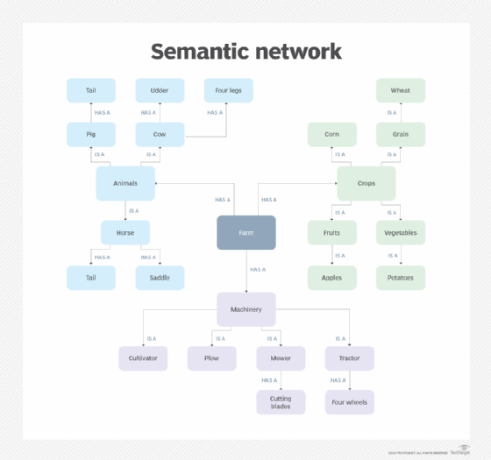

(Slide)Semantic Network Examples
Q-1:
Represent the following English sentences using a semantic network:
"Frosty is a snowman. A snowman is made of snow. Snow is frozen water. It is slippery and soft. Snow is cold. Ice is also cold. It is also frozen water, but unlike snow, which is soft, ice is hard. Ice is clear in color."

Water
soft
slippery
white
snow
snowman
cold
frosty
ice
hard
clear
form of
made of
instance of
color
hardness
texture
temperature
temperature
color
hardness
form of
texture
Fig. Semantic network

Q-2:
Represent the following English sentences using a semantic network:
Tom is a cat. Tom caught a bird. Tom is owned by John. Tom is ginger in colour. Cats like cream. The cat sat on the mat. A cat is a mammal. A bird is an animal. All mammals are animals. Mammals have fur.
Fur
Animal
Cat
Bird
Mammal
Mat
John
Cream
Tom
Ginger
has
sat_on
like
is_a
caught
is_coloured
is_owned_by
Fig. Semantic network
is_a
is_a
is_a

Prolog representation:
cat(tom).
cat(cat1).
mat(mat1).
sat_on(cat1, mat1).
bird(bird1).
caught(tom, bird1).
like(X, cream) :– cat(X).
mammal(X) :– cat(X).
has(X, fur) :– mammal(X).
animal(X) :– mammal(X).
animal(X) :– bird(X).
owns(john, tom).
is_coloured(tom, ginger).

Q-3:
Following are some statements which we need to represent in the form of nodes and arcs.
Statements:
Jerry is a cat.
Jerry is a mammal
Jerry is owned by Priya.
Jerry is brown colored.
All Mammals are animal.
Fig. Semantic network
Mammal
Animal
Cat
Brown
Jerry
is_a
is_a
is_a
Priya
is-owned
is-colored

Q-4:
Represent the following English sentences using a semantic network:
A trout is a fish. A fish has gills. A fish has fins. Fish is food. Fish is animal. An apple is a fruit. Fruit has a stem. Fruit is food. Fruit is vegetable. An animal is a living thing. A vegetable is a living thing.

Fig. Semantic network
stem
fruit
living_thing
fins
food
apple
vegetable
trout
animal
gills
is
fish
is_a
is_a
is
is
has_a
has
has
has
is
is_a
is_a

Q-5:
Represent the following English sentences using a semantic network:
- A tiger is a cat.
- A tiger has stripes.
- A tiger is wild.
- A tabbie is a cat.
- A tabbie has stripes.
- A tabbie is a pet.
- A flag has stripes.
- A flag is an artifact.
- A cat is a mammal.
- A mammal is an animal.
- A dog is a mammal.
- A dog is a pet.
- A dog barks.

Q-6:
Construct semantic network based on the following scenario. Use round for an object and line for the relationship.
Kasem is 45 year-old man who has 2 wives and 7 kids. He works as a surgeon in a private hospital and owns a Naza Ria. Naza Ria is distributed by the Naza Motors. This car has a capacity of 7 seats, black in colour and 2.5 cylinder. Naza Motors also distributes Brabus, Peugeot, Ferrari, Maserati, Chevrolet, Citroen and few more.

Q-7:
Construct semantic network for the following English sentences:
Tom is an instance of dog.
Tom caught a cat.
Tom is owned by Rashan.
Tom is brown in colour.
Dogs like bones.
The dog sat on the mat.
A dog is a mammal.
A cat is an instance of animal.
All mammals are animals.
Mammals have fur.

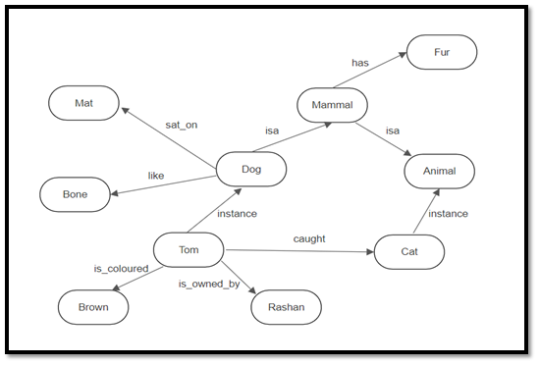

Q-8:
Illustrate the following semantic network:

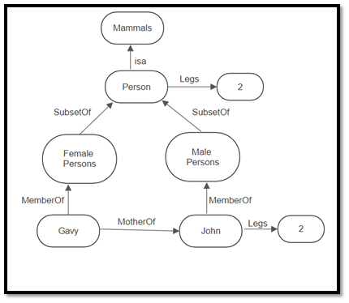

Q-9:
Represent the following sentences into a semantic network:
- Marcus was a man
- Marcus was a Pompeian
- All Pompeians were Romans
- Caesar was a ruler
- Marcus tried to assassinate Caesar
- All men are persons
- Height of Marcus was 72.

Roman
isa
person
Marcus
ruler
Pompeian
man
72
Caesar
isa
instanc-of
instanc-of
instanc-of
height
try-assasinate

Q-10:
Represent the following sentences into a semantic network:
- Birds are animals.
- Birds have feathers, fly and lay eggs.
- Albatros is a bird.
- Donald is a bird.
- Tracy is an albatros.

bird
isa
yes
feathers
albatros
eggs
Donald
animal
Tracy
instanc-of
isa
has
lay
isa
fly

Q-11:
Following are some statements which we need to represent in the form of nodes and arcs.
Statements:
Jerry is a cat.
Jerry is a mammal.
Jerry is owned by Jay.
Jerry is white colored.
All Mammals are animal.
Jerry likes cheese.
Mammal
Animal
Cat
white
Jerry
is_a
is_a
is_a
Jay
is-owned
is-colored
cheese
like

Questions on Semantic Net(Slide)

- Explain the knowledge representation using semantic net with the help of an example.
- How do we precisely define the semantics of a semantic network?
- Draw an associative network for the following sentences:
- Tweety is a yellow bird that has wings and tail.
- Tweety ate a fat worm.
- John is going to Boston by bus.
- Differentiate between Semantic Networks and Frames.
- Write a short note on different knowledge representation techniques.

Question: Express the following in i) Frame and ii) Semantic/Associative Net:
Rabindranath Tagore was a Bengali Poet, Novelist, Musician, and Playwright. Tagore was born in Jorasanko in Kolkata, India on 7th May 1861. As auother of Gitanjali, he was first Bengali to get Nobel in Literature in 1913.

Question: Express the following in i) Frame and ii) Semantic/Associative Net:
Shahjahan Mia, Father of Titu, is a farmer who has a land. He resided at Bajitpur, Mymensingh. He was living a happy and peaceful life. His age was 50 years. He was friend of Jakir Hossain. Mr. Jakir is also a farmer, but he does not have any land.

Question: Express the following in i) Frame and ii) Semantic/Associative Net:
Bird and Fish are animal which is covered by skin. Robin is a bird which is red in color and travels by flying. Hilsha is a fish which is silver in color and travels by swimming.

Q. a) Represent the following expression in (i) Semantic net and (ii) Frame based approach:
Ferdausi Rahman, a renowned singer of Bangladesh, is the daughter of Abbas Uddin who is a famous folk singer. She prefers singing modern, Nazrul and folk songs. She is liked by all Bangladeshis because of her wonderful tone.

b) How will you represent the above knowledge in PROLOG?

Q. Construct semantic net representations for the following:
- Mary gave the green flowered vase to her favorite cousin.
- All the batters like the pitcher.

Q.
Represent the following expression in (i) Semantic net and (ii) Frame based approach:
Samina Chowdhury, the daughter of Mahmudun Nabi and Rashida Chowdhury, is a renowned singer. She was born in Dinajpur on 1968. She prefers to sing classical and modern songs. She is liked by all Bangladeshis because of her sweet melodies.

Q.
Translate the following knowledge into semantic net and frame:
Bird and Fish are animal which is covered by skin. Robin is a bird which is red in color and travels by flying. Hilsha is a fish which is silver in color and travels by swimming.

Q. Draw an associative network for the following expression:
i) Hasan is a student. He is a friend of Rita. His age is 21.
ii) The Queen Mary is an ocean liner. Every ocean liner is a ship

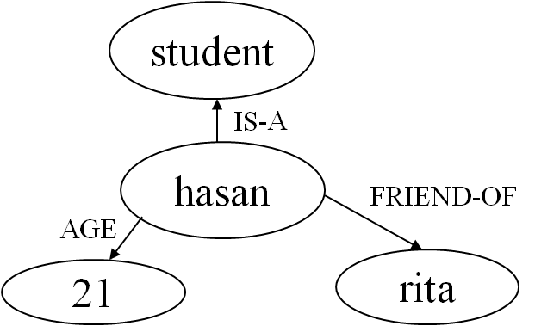
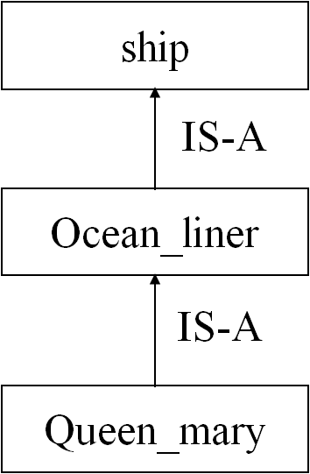
- Ii)

